

**Overview**

This project is about to perform CI-CD Pipeline using Azure in this we have deploy our application using CI CD pipeline and when we commit the code or when we click on run pipeline it will deploy the application

Architecture Diagram:

In this we have created app service from App registration and from that we got the client id and client secret

When we do the git commit immediately pipeline will trigger and it will deploy the application with the help of hosted agent

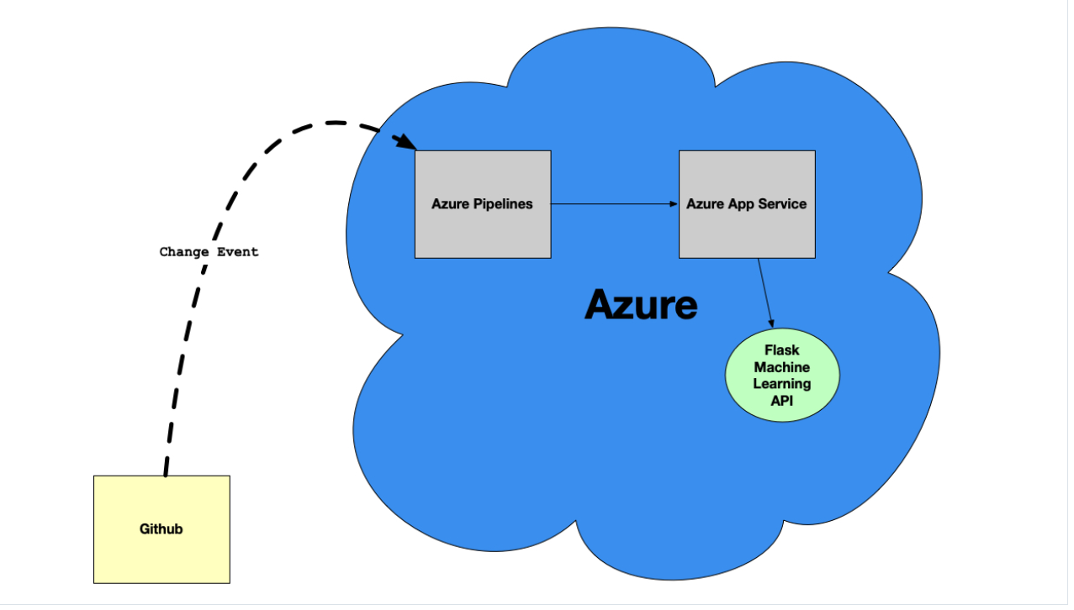

**Project Plan**

* The trello board for the project can be found below

<https://trello.com/b/PnU3TNCY/udacity-project-ci-cd>

* The project plan can be found below

<https://docs.google.com/spreadsheets/d/1VIMYaIjncJFG6NLlaoOz7Pp-RVefwCHhqqFBbdBeqYE/edit?usp=sharing>

Output of the .sh file is showing here

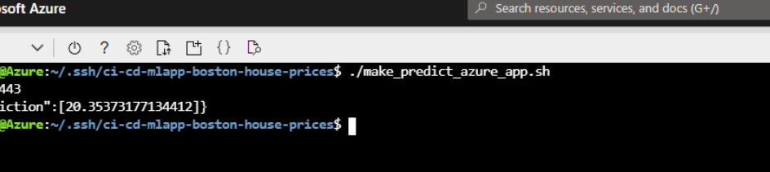

**Instructions**

1. Firstly we have to clone the project from github
2. Create the app registration and from that we will get client id, client secret
3. Then go to subscription>>API access and then do the role assignment for the app which we have register
4. Then go to azure Devops organization
5. Create the organization and create the pipeline
6. Then create the Microsoft agent
7. Assign that agent to default pool
8. Then create a VM and then assign to that pool
9. Then run the pipeline which we have created
10. Then execute the make all command and it will run the sample project

**Project running on Azure App Service**

**Project cloned into Azure Cloud Shell**

The screenshots of clone using ssh is below

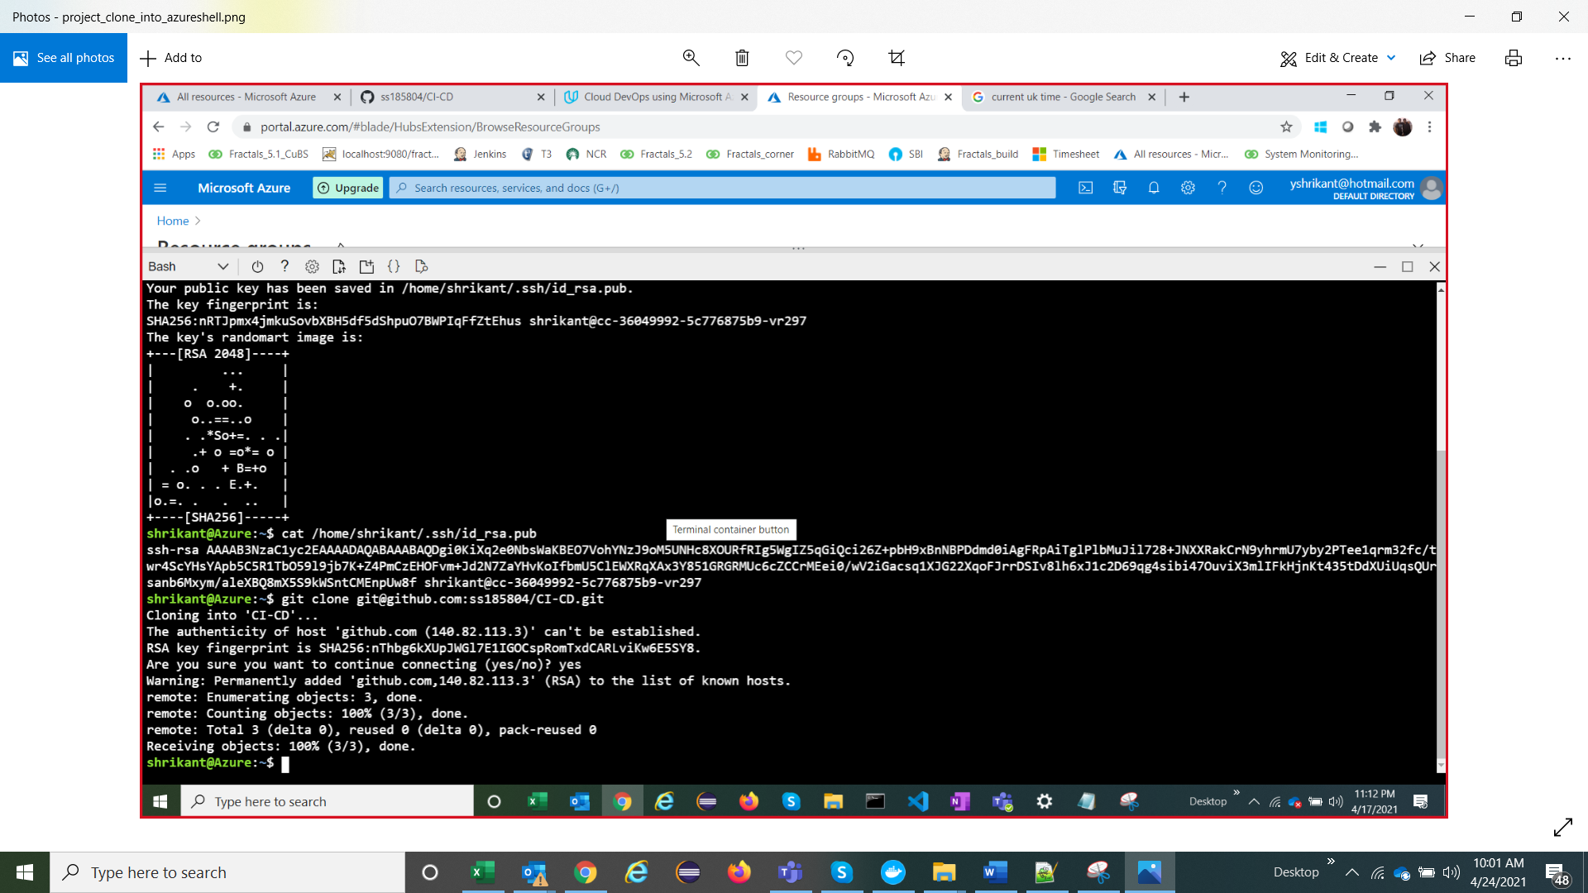

**Passing tests that are displayed after running the make all command from the Makefile**

**Output of a test run**

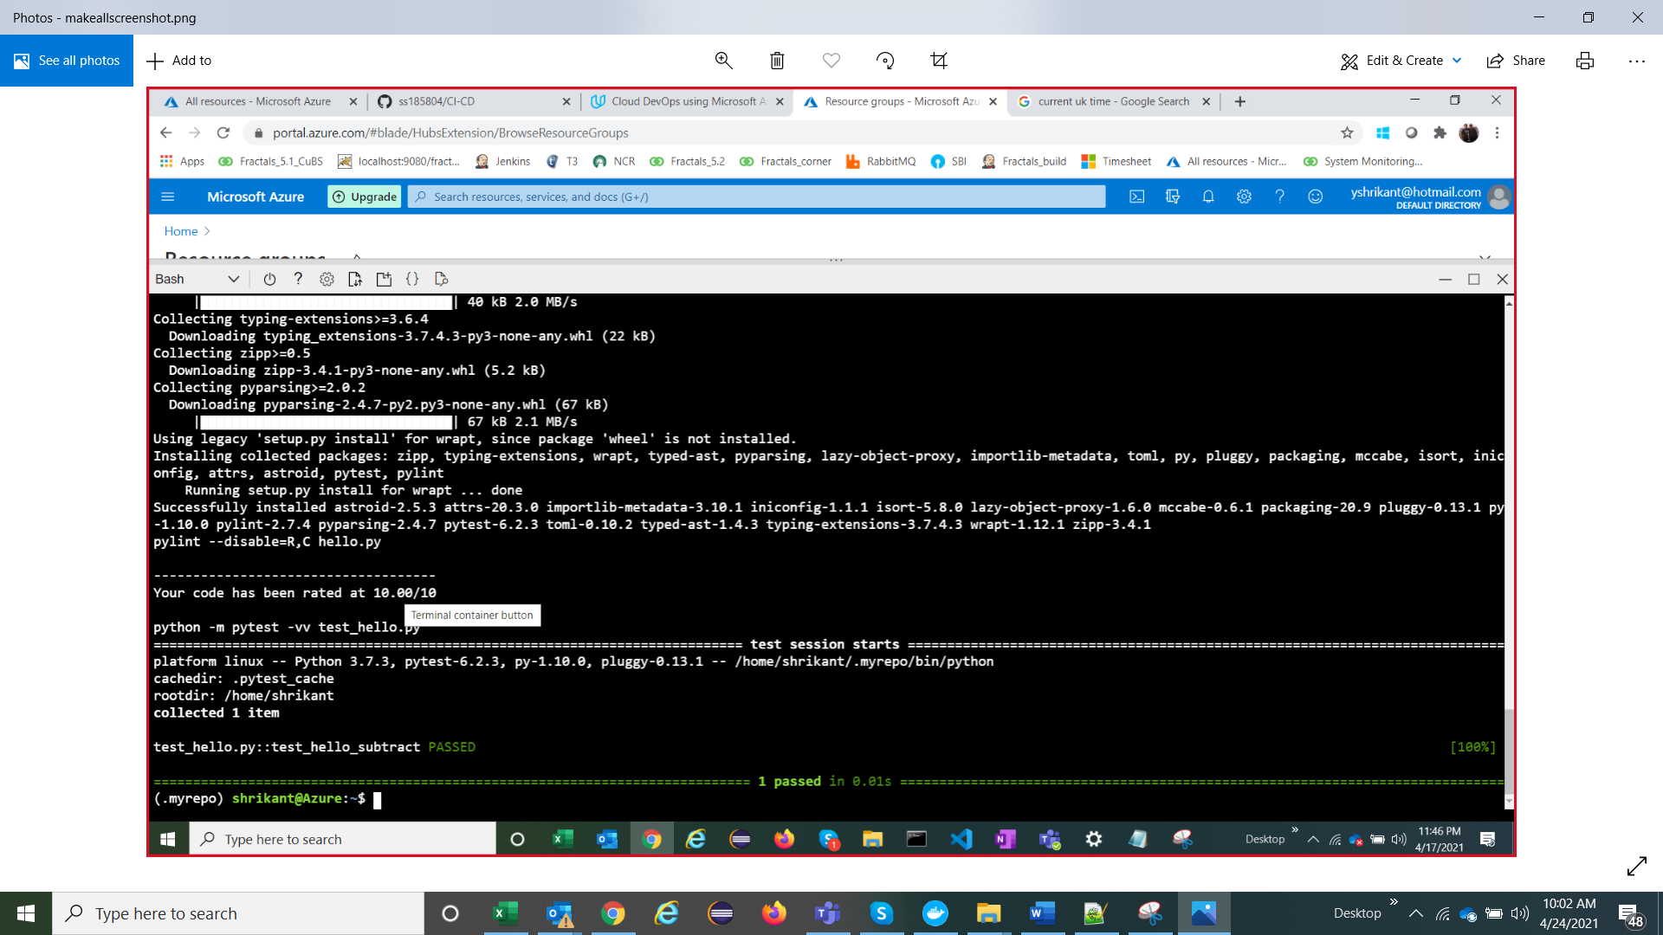

**GitHub Actions Run**

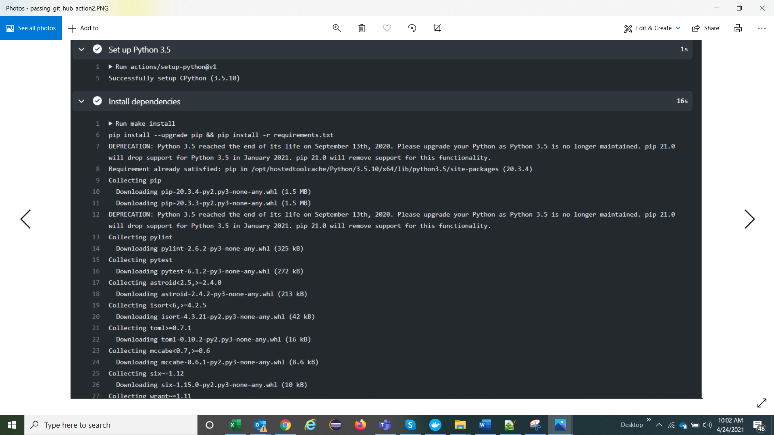

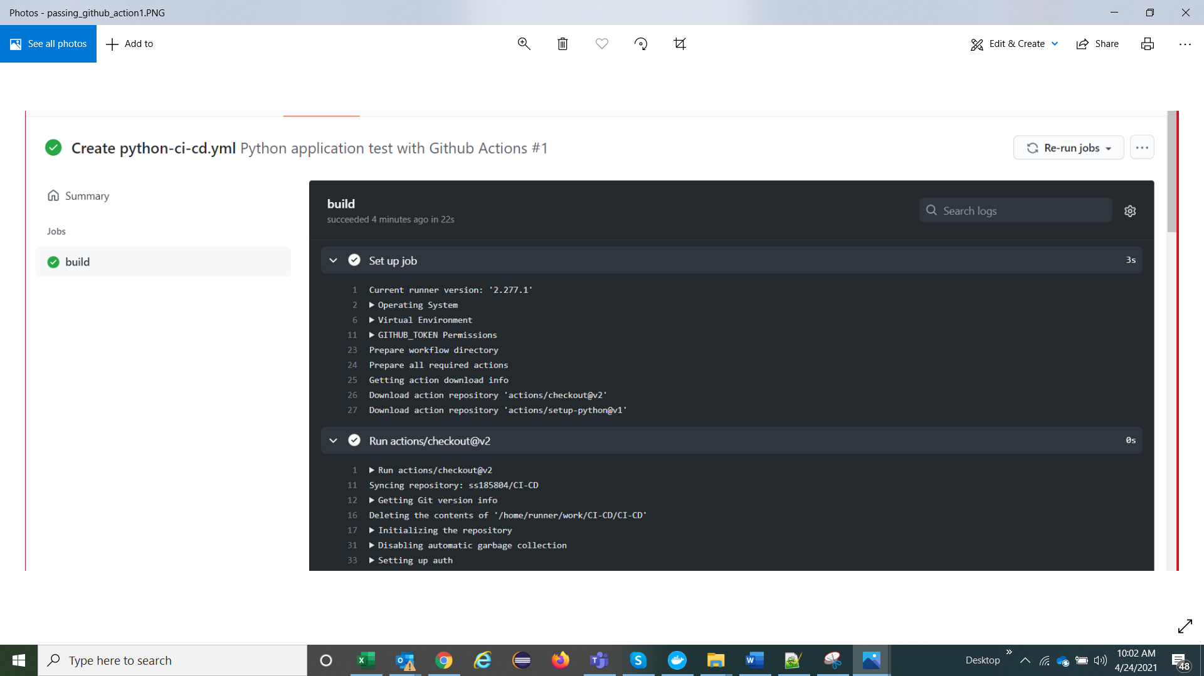

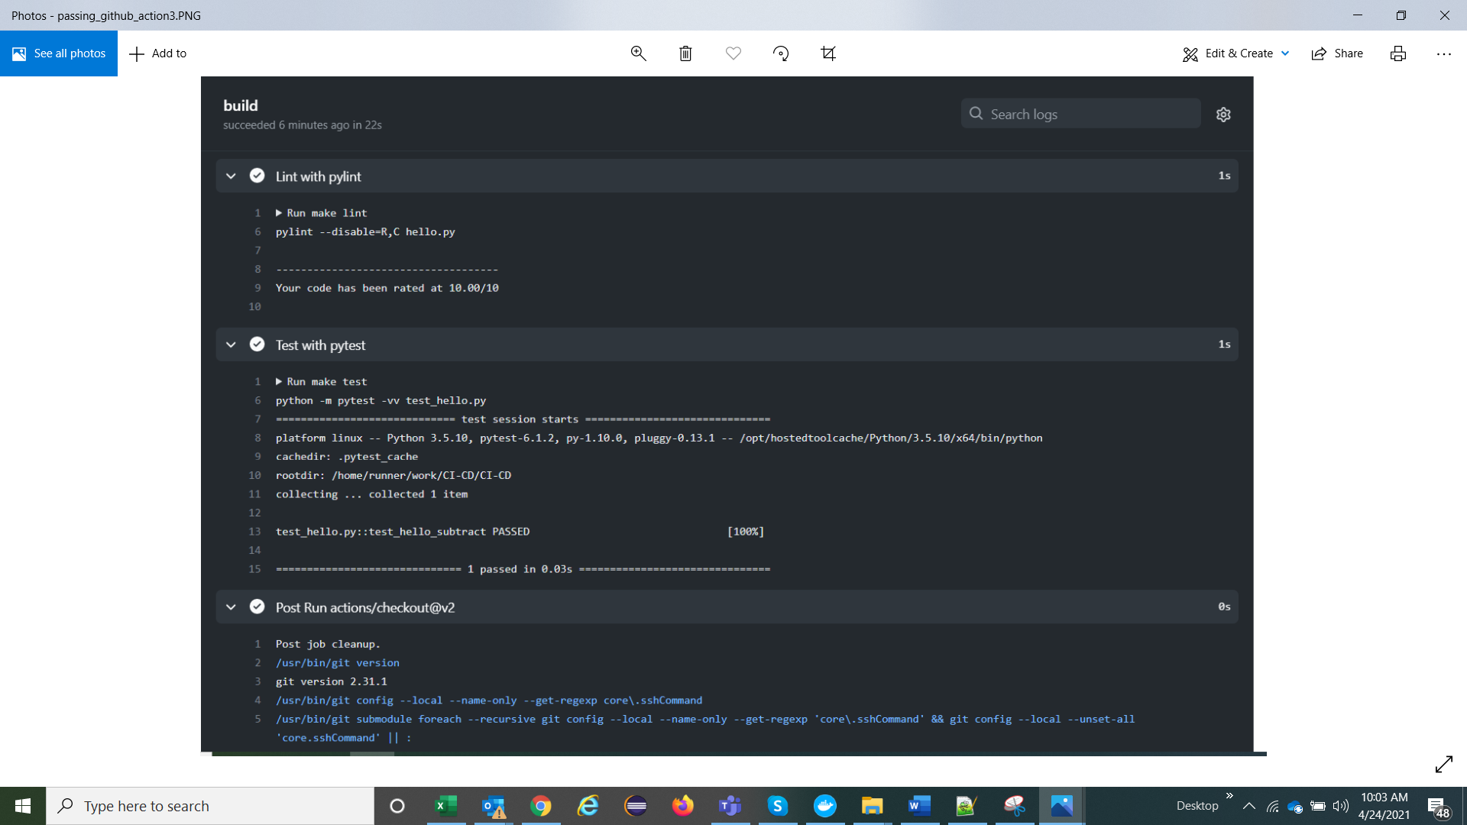

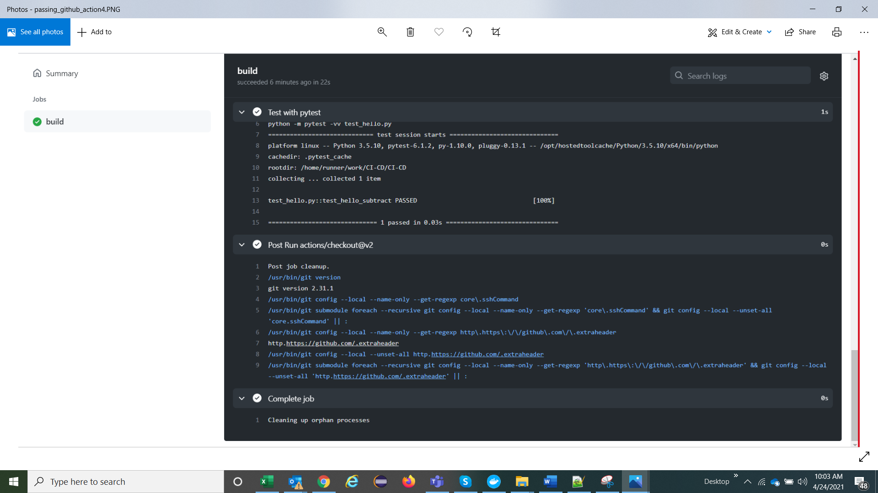

**Running Azure App Service from Azure Pipelines automatic deployment**

**Successful prediction from deployed flask app in Azure Cloud**

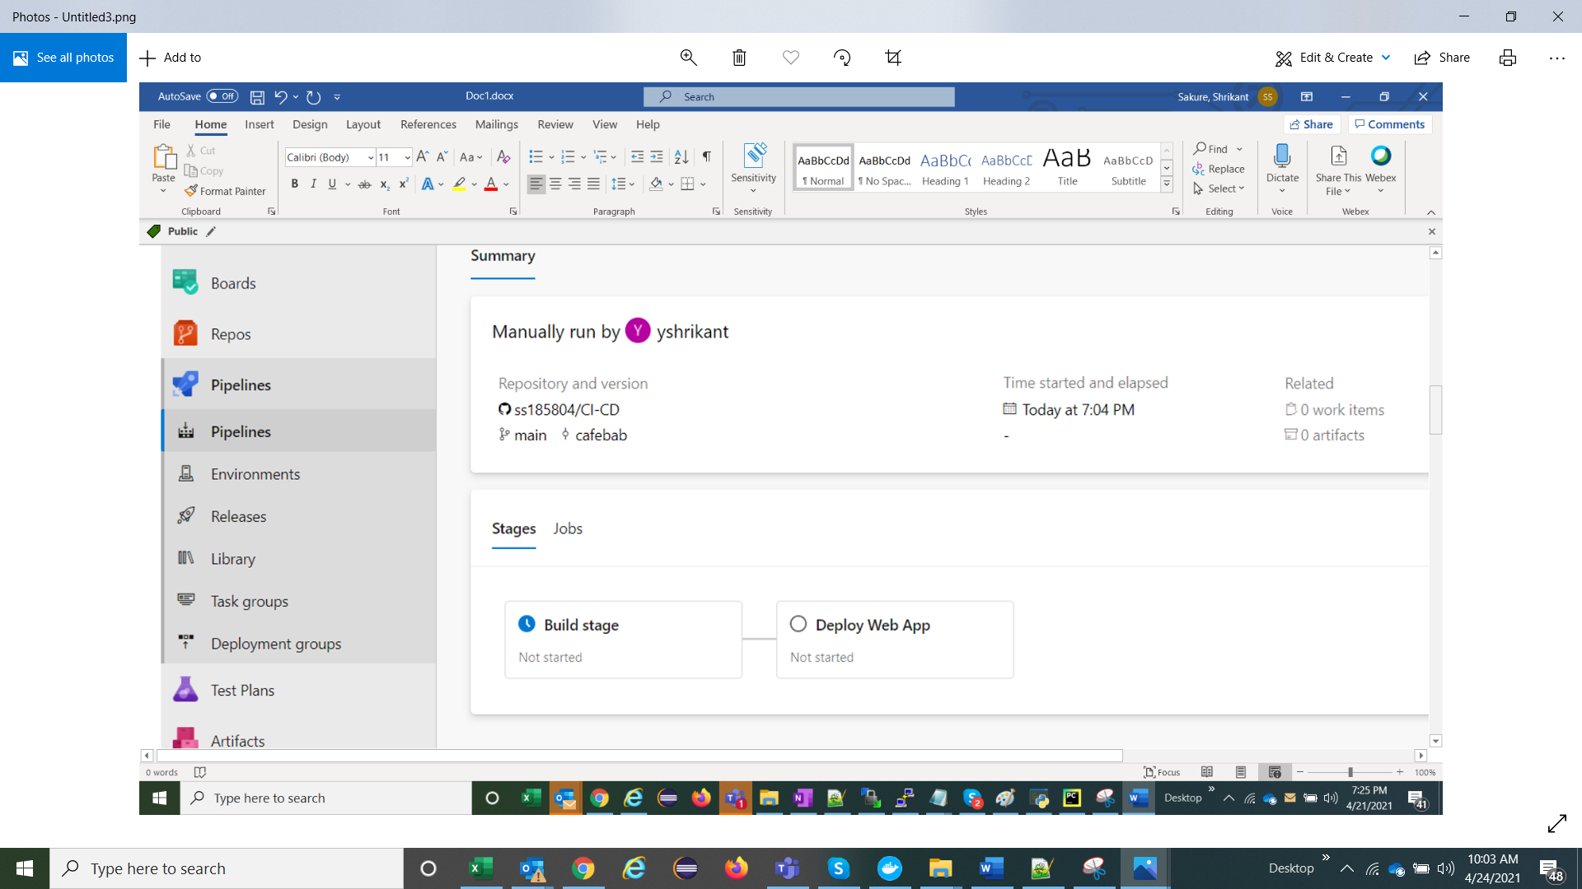

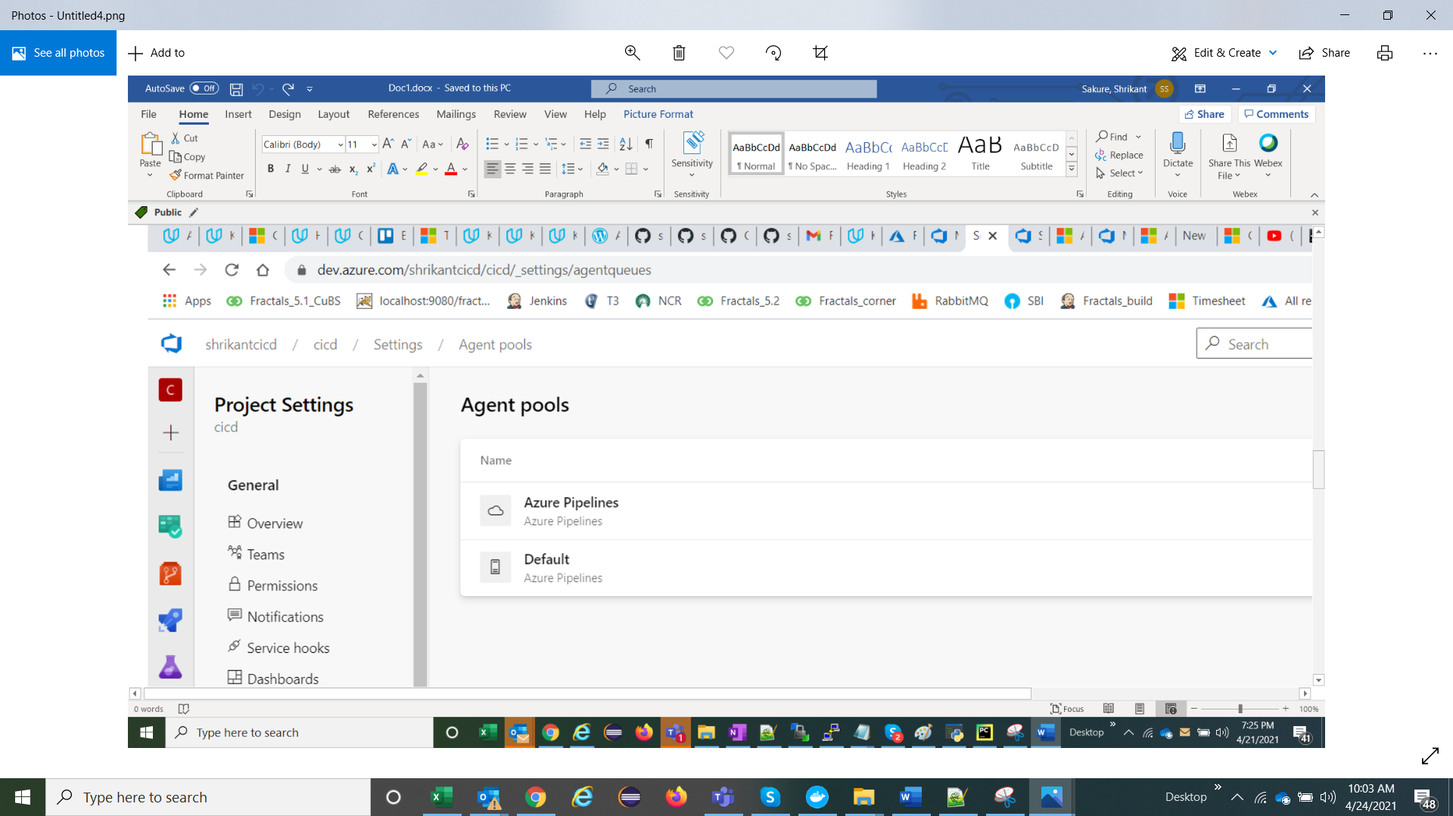

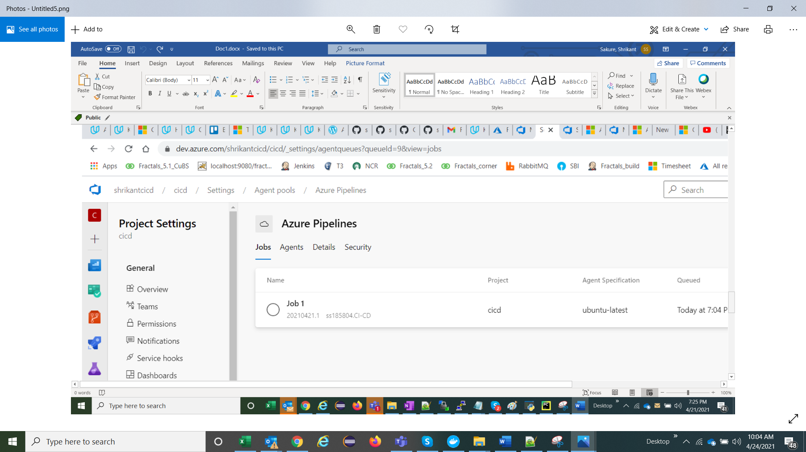

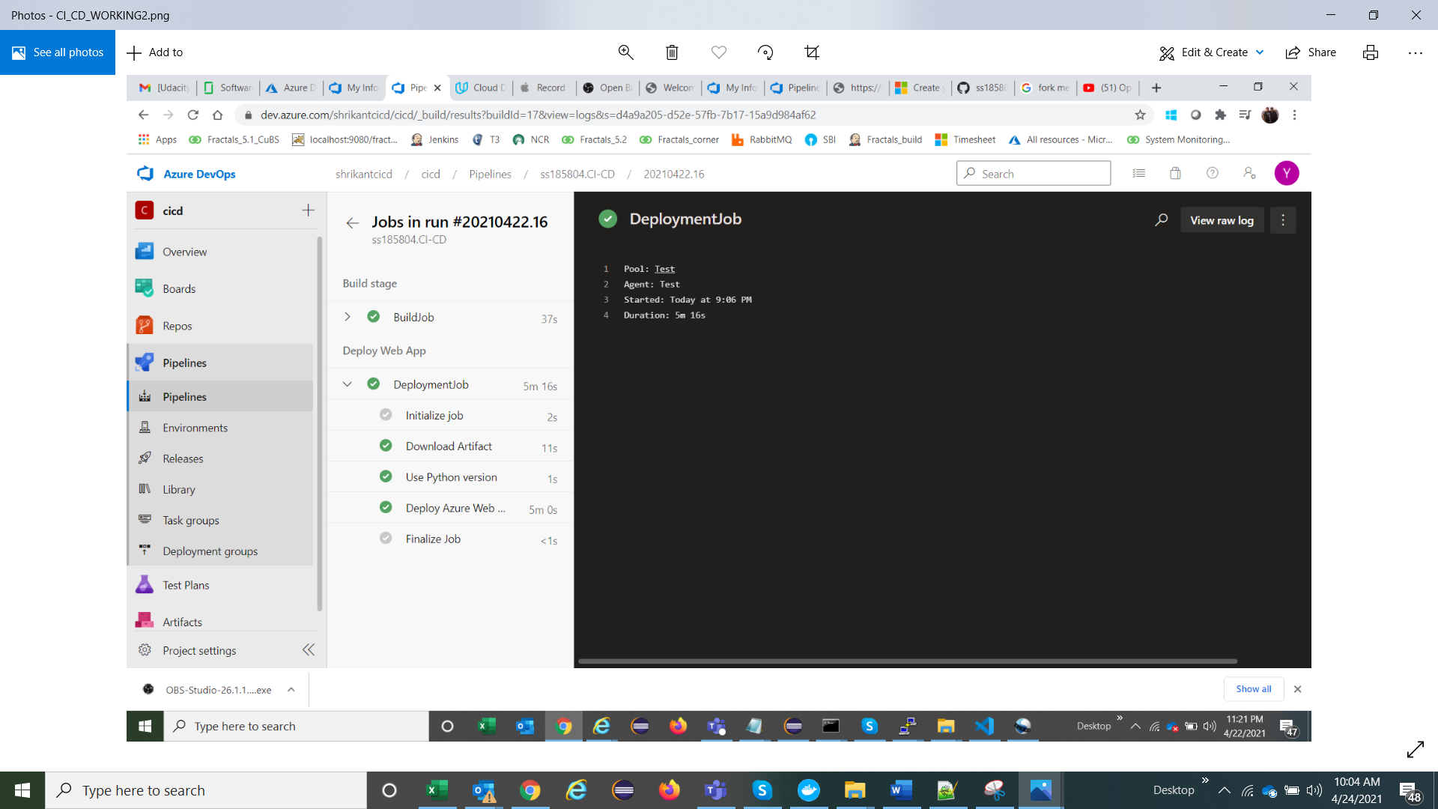

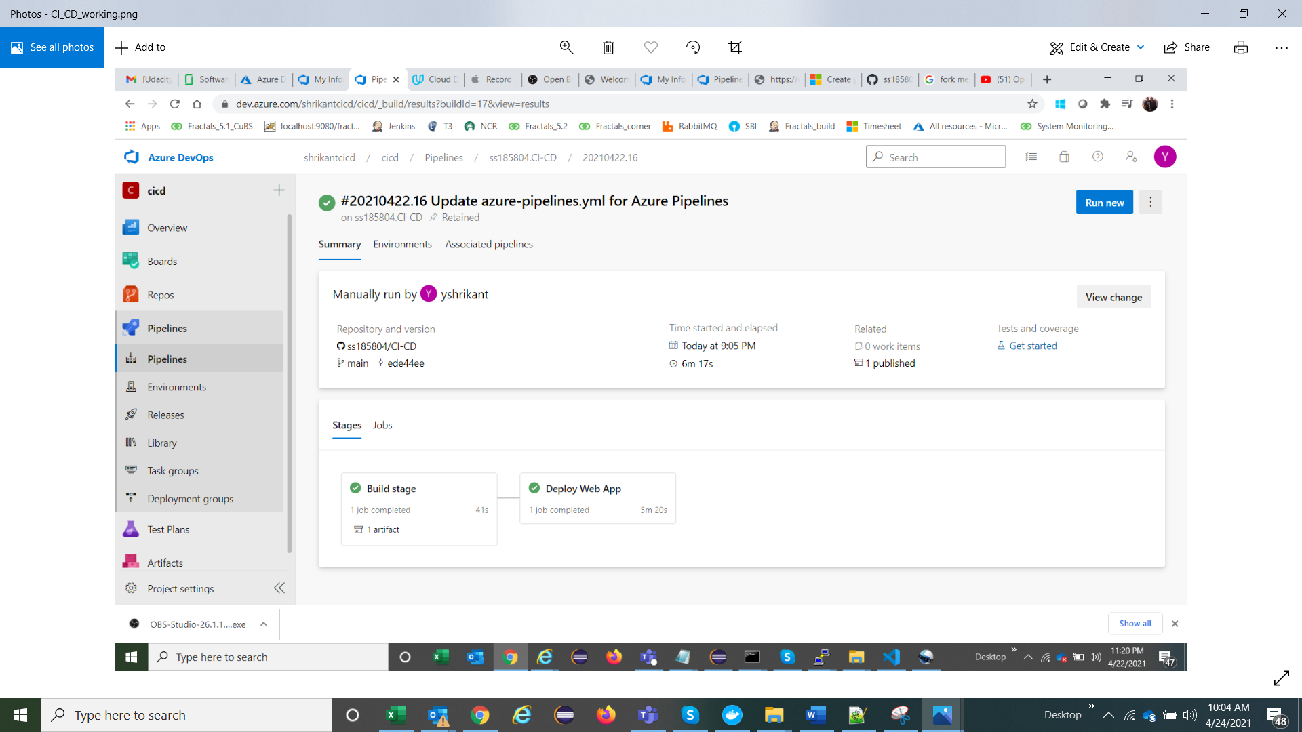

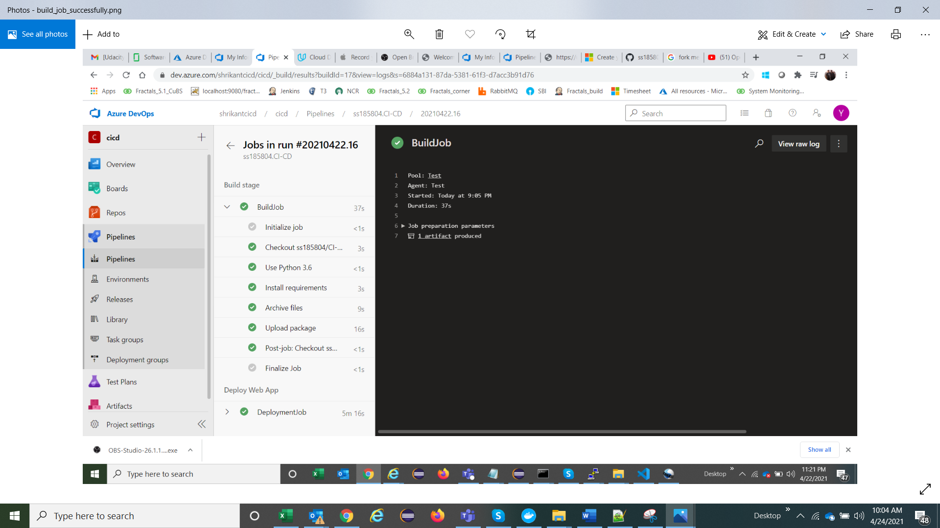

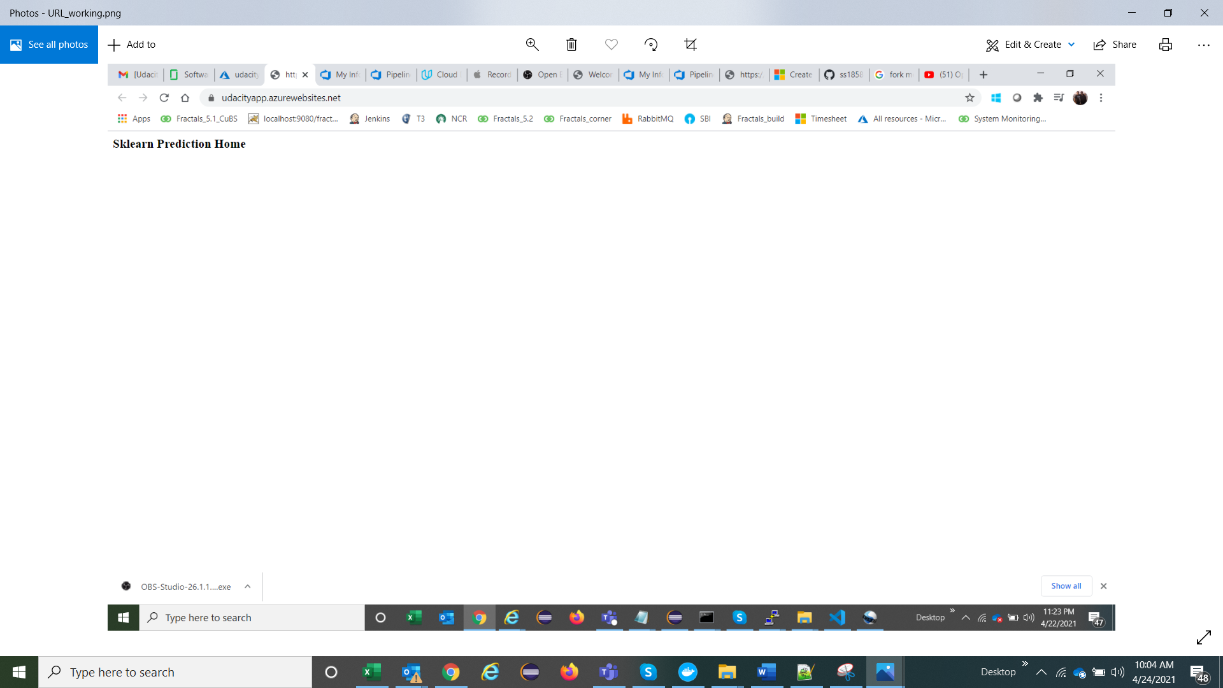

Video on you tube found at this link

<https://youtu.be/Y0LGzaq7ook>

Enhancement for future

In future instead of simple app will try to run our automation suite

App registration Screenshot

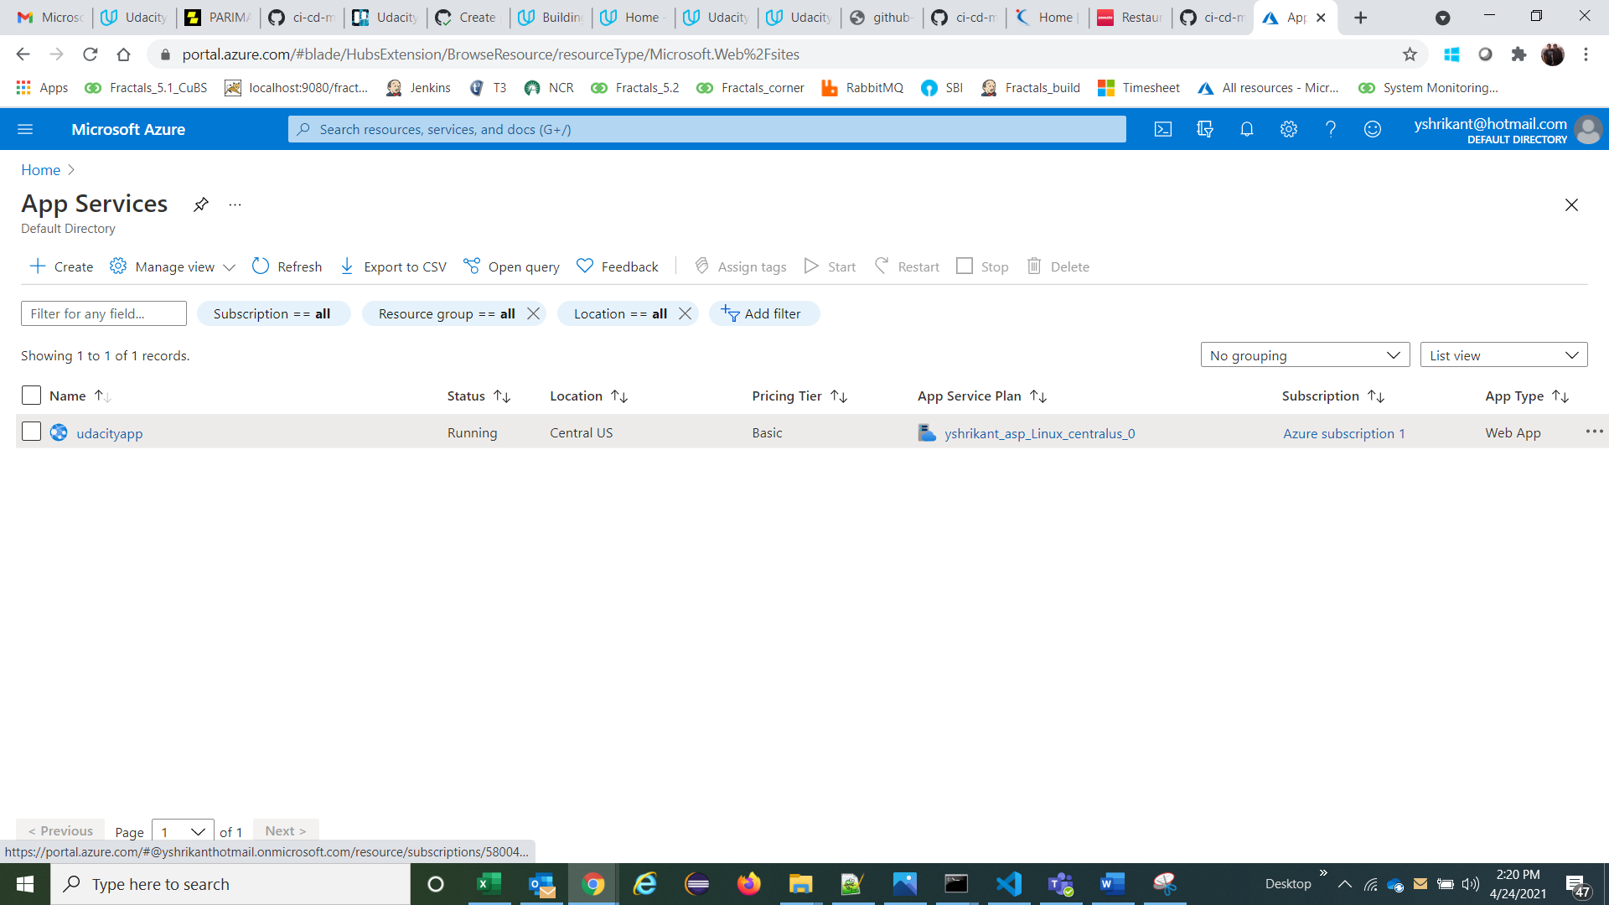

Locust File

. To run the performance install locust on machine and we have to start locust on machine (refer below screenshot)

